Contents of This Document
implementation of Phase 2 of the Stock Market Tweets analysis project. It includes:
- FABRIC testbed setup and SSH access to the compute node
- Dataset download - 923,673 Stock Market tweets (April–July 2020)
- PySpark pipeline - data cleaning, hashtag/cashtag extraction, time-based aggregation
- Output files - daily/weekly parquet files handed off to Nolan for Ray/ML
- Visualizations - bar chart, pie chart, trend line, and heatmap of tweet activity
- Code - full Spark pipeline and visualization scripts

"923,673 tweets with 3 columns: id, created_at, text. Date range: April–July 2020."
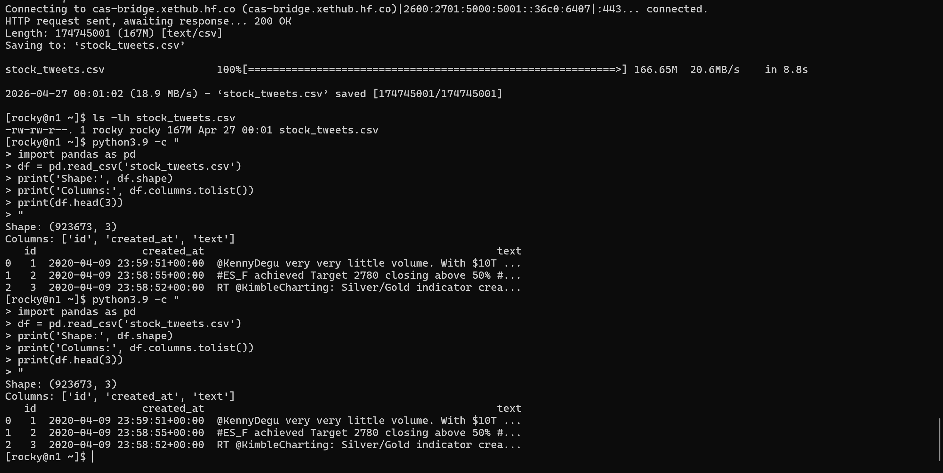

cat > spark_pipeline.py << 'EOF'
from pyspark.sql import SparkSession
from pyspark.sql.functions import udf, explode, col, to_date, date_trunc
from pyspark.sql.types import ArrayType, StringType
import re, os

spark = SparkSession.builder \
.appName("StockTweetPipeline") \
.config("spark.sql.parquet.datetimeRebaseModeInWrite", "CORRECTED") \
.config("spark.sql.parquet.int96RebaseModeInWrite", "CORRECTED") \
.getOrCreate()
spark.sparkContext.setLogLevel("ERROR")

df = spark.read.csv("stock_tweets.csv", header=True, inferSchema=True)
print("Total rows:", df.count())

df = df.dropna(subset=["text"]).dropDuplicates(["text"])

def extract_hashtags(text):
return re.findall(r"#\w+", text.lower()) if text else []

def extract_cashtags(text):
return re.findall(r"\$[A-Z]{1,5}", text.upper()) if text else []

hashtag_udf = udf(extract_hashtags, ArrayType(StringType()))
cashtag_udf = udf(extract_cashtags, ArrayType(StringType()))

df = df.withColumn("hashtags", hashtag_udf("text"))
df = df.withColumn("cashtags", cashtag_udf("text"))
df = df.withColumn("date", to_date(col("created_at")))
df = df.withColumn("week", date_trunc("week", col("date")))

os.makedirs("output", exist_ok=True)

df.select("date", explode("hashtags").alias("tag")) \
.groupBy("date", "tag").count().orderBy("date", col("count").desc()) \
.write.mode("overwrite").parquet("output/daily_hashtag_counts.parquet")

df.select("date", explode("cashtags").alias("tag")) \
.groupBy("date", "tag").count().orderBy("date", col("count").desc()) \
.write.mode("overwrite").parquet("output/daily_cashtag_counts.parquet")

df.select("week", explode("hashtags").alias("tag")) \
.groupBy("week", "tag").count().orderBy("week", col("count").desc()) \
.write.mode("overwrite").parquet("output/weekly_hashtag_counts.parquet")

df.select("date", "text", "hashtags", "cashtags") \
.write.mode("overwrite").parquet("output/cleaned_tweets.parquet")

print("\nTop 10 Hashtags:")
df.select(explode("hashtags").alias("tag")).groupBy("tag").count() \
.orderBy(col("count").desc()).show(10)

print("\nTop 10 Cashtags:")
df.select(explode("cashtags").alias("tag")).groupBy("tag").count() \
.orderBy(col("count").desc()).show(10)

print("\nDone. Outputs saved to ./output/")
spark.stop()
EOF

>>
export PYSPARK_PYTHON=/usr/bin/python3.9
export PYSPARK_DRIVER_PYTHON=/usr/bin/python3.9
python3.9 spark_pipeline.py

"Fixed Spark datetime rebase error by setting parquet datetime mode to CORRECTED -required for Spark 3.x writing timestamps."
"Spark pipeline completed successfully. Top hashtags: #stocks (156K), #stockmarket (35K). Top cashtags: $SPX (73K), $AAPL (63K), $AMZN (52K). 1.8M rows processed after deduplication."
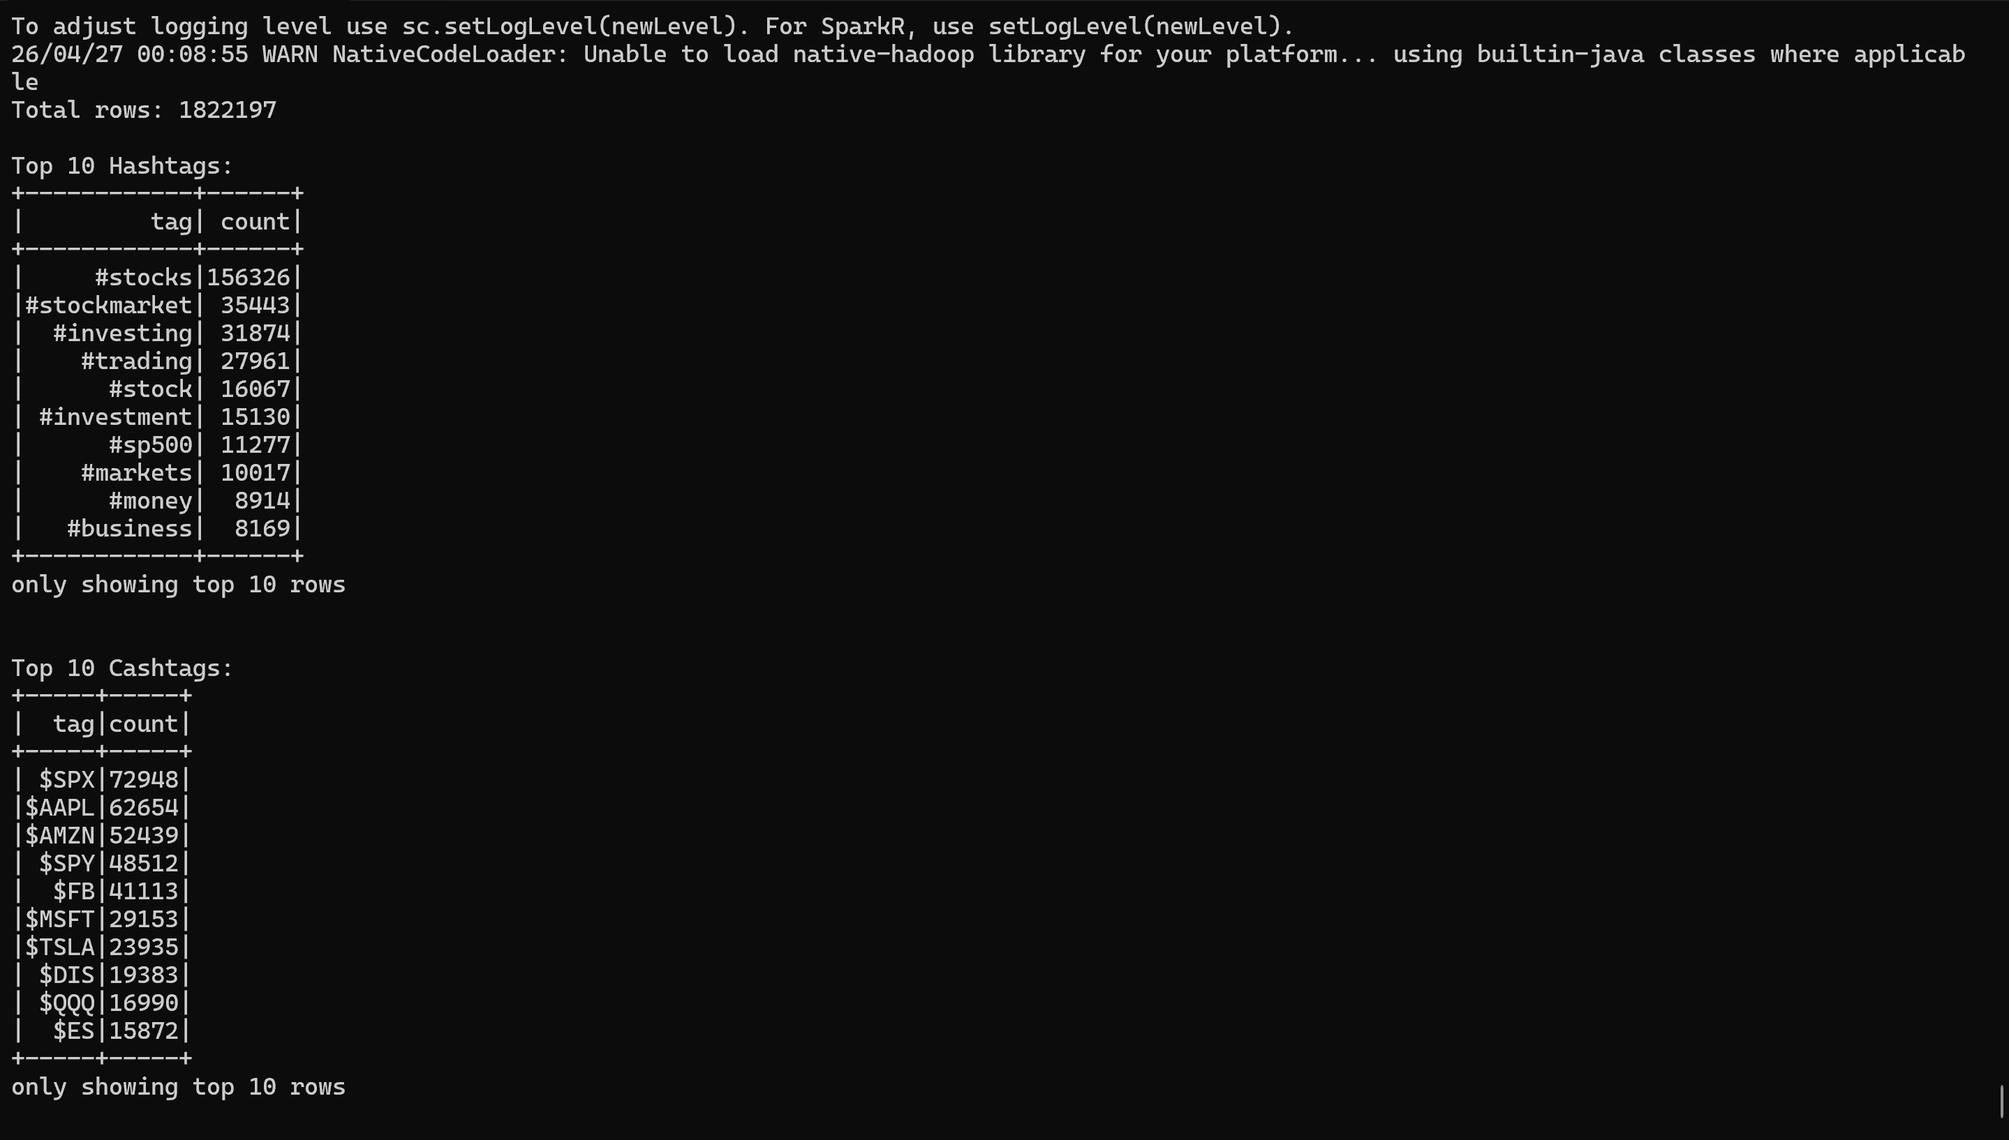

“Output parquet files saved: daily/weekly hashtag and cashtag counts”
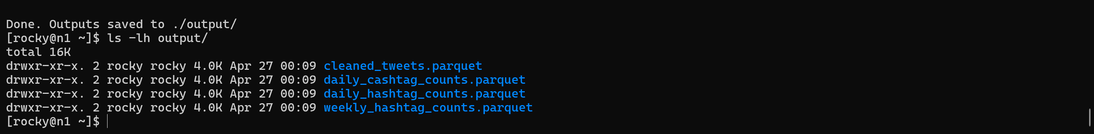

the visualization script:
>>
cat > visualizations.py << 'EOF'
import pandas as pd
import matplotlib
matplotlib.use('Agg')
import matplotlib.pyplot as plt
import seaborn as sns
import os

os.makedirs("plots", exist_ok=True)

# Load data
daily_h = pd.read_parquet("output/daily_hashtag_counts.parquet")
daily_c = pd.read_parquet("output/daily_cashtag_counts.parquet")

# 1. Bar chart - Top 20 Hashtags
top_hashtags = daily_h.groupby("tag")["count"].sum().sort_values(ascending=False).head(20)
plt.figure(figsize=(14,6))
sns.barplot(x=top_hashtags.values, y=top_hashtags.index, palette="Blues_r")
plt.title("Top 20 Hashtags in Stock Market Tweets")
plt.xlabel("Total Count")
plt.ylabel("Hashtag")
plt.tight_layout()
plt.savefig("plots/top20_hashtags.png", dpi=150)
plt.close()
print("Saved top20_hashtags.png")

# 2. Pie chart - Top 10 Cashtags
top_cashtags = daily_c.groupby("tag")["count"].sum().sort_values(ascending=False).head(10)
plt.figure(figsize=(10,8))
plt.pie(top_cashtags.values, labels=top_cashtags.index, autopct='%1.1f%%', startangle=140)
plt.title("Top 10 Cashtags Distribution")
plt.tight_layout()
plt.savefig("plots/top10_cashtags_pie.png", dpi=150)
plt.close()
print("Saved top10_cashtags_pie.png")

# 3. Line chart - Daily tweet activity for top 5 hashtags
top5 = daily_h.groupby("tag")["count"].sum().sort_values(ascending=False).head(5).index.tolist()
filtered = daily_h[daily_h["tag"].isin(top5)].copy()
filtered["date"] = pd.to_datetime(filtered["date"])
pivot = filtered.pivot_table(index="date", columns="tag", values="count", fill_value=0)
plt.figure(figsize=(14,6))
pivot.plot(ax=plt.gca())
plt.title("Daily Trend of Top 5 Hashtags Over Time")
plt.xlabel("Date")
plt.ylabel("Count")
plt.legend(loc="upper right")
plt.tight_layout()
plt.savefig("plots/hashtag_trends.png", dpi=150)
plt.close()
print("Saved hashtag_trends.png")

# 4. Heatmap - Top 10 hashtags by week
weekly_h = pd.read_parquet("output/weekly_hashtag_counts.parquet")
top10 = weekly_h.groupby("tag")["count"].sum().sort_values(ascending=False).head(10).index.tolist()
filtered_w = weekly_h[weekly_h["tag"].isin(top10)].copy()
filtered_w["week"] = pd.to_datetime(filtered_w["week"]).dt.strftime("%Y-%m-%d")
pivot_w = filtered_w.pivot_table(index="tag", columns="week", values="count", fill_value=0)
plt.figure(figsize=(14,6))
sns.heatmap(pivot_w, cmap="YlOrRd", linewidths=0.5, annot=False)
plt.title("Weekly Hashtag Activity Heatmap")
plt.xlabel("Week")
plt.ylabel("Hashtag")
plt.tight_layout()
plt.savefig("plots/hashtag_heatmap.png", dpi=150)
plt.close()
print("Saved hashtag_heatmap.png")

print("\nAll 4 plots saved to ./plots/")
EOF
